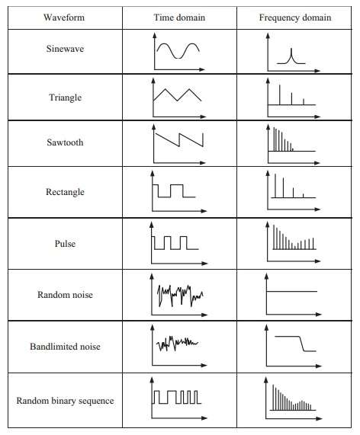

**Time Domain**

The **time domain** is the domain in which all the signals are represented. Time domain signal can be tested or verified with the use of oscilloscope.

In time domain signals are represented by amplitude on Y axis and time on X axis.

**Frequency Domain**

The **frequency domain** is useful to do more deeper analysis of the time domain signal. Frequency domain helps study frequency contents of the discrete time domain signals as well as continuous time domain signal. **The frequency domain signal can be analyzed with the use of spectrum analyzer.**

In frequency domain signals are represented by power (amplitude2) on Y axis and frequency on X axis.

Time domain signal can be converted to Frequency domain signal with the use of Discrete Fourier Transform or Fast Fourier Transform (FFT).

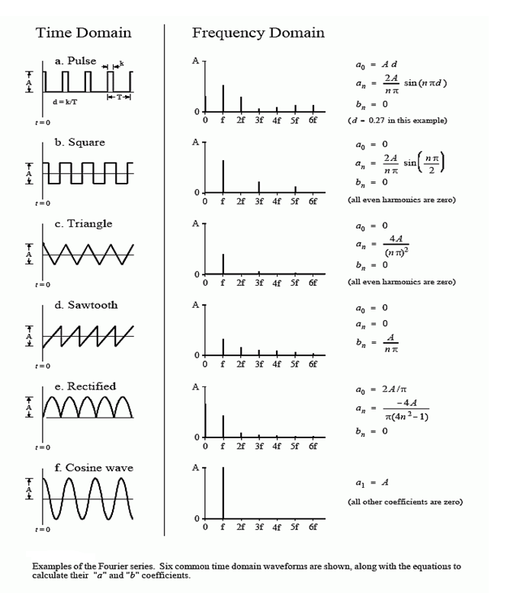

The time domain signal used in the Fourier series is periodic and continuous. Following figure shows several examples of continuous waveforms that repeat themselves from negative to positive infinity. Periodic signals have a frequency spectrum consisting of **harmonics**. For instance, if the time domain repeats at 10 Mhertz (a period of 1 microsecond), the frequency spectrum will contain a first harmonic at 10 Mhertz, a second harmonic at 20 Mhertz, a third harmonic at 30 Mhertz, and so forth. The first harmonic, i.e., the frequency that the time domain repeats itself, is also called the **fundamental frequency**. This means that the frequency spectrum can be viewed in two ways: (1) the frequency spectrum is continuous, but zero at all frequencies except the harmonics, or (2) the frequency spectrum is discrete, and only defined at the harmonic frequencies. In other words, the frequencies between the harmonics can be thought of as having a value of zero, or simply not existing. The important point is that they do not contribute to forming the time domain signal.

